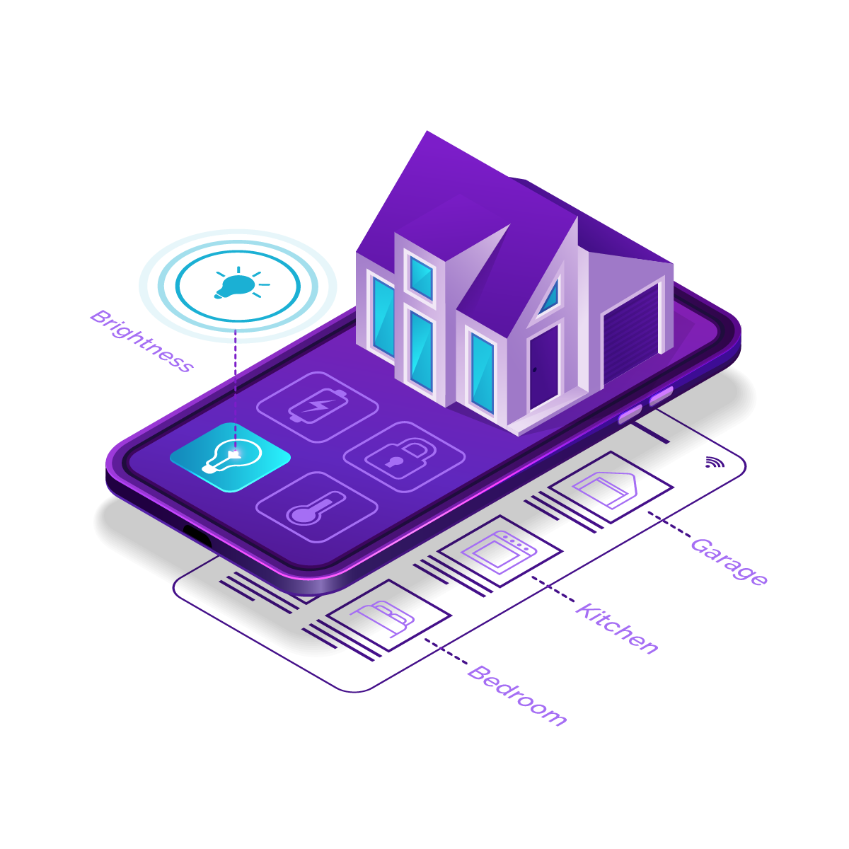



**SUBMITTED BY: PRATEEK MISHRA**

**REPORT OF SMARTDOOR AUTOMATION**

**IoT INTERNSHIP (HOME AUTOMATION)**

**GROUP 5 B.TECH 3rd YEAR**

**05-07-2021 TO 31-07-2021**

**INTERNSHIP ORGANISED BY DCS (CSED)**

**GLA UNIVERSITY, MATHURA**

**AKNOWLEDGEMENT**

I want to Thank Anupam sir and All faculties and Managements of DCS(CSED) for their patience and assistance during our on-site Internship. Thanks to their guidance, I was able to develop Smart Door using Power of IOT and learn about Cloud, IOT, Industrial Experience. These skills will help me to expand My resume and advance my career.

**TABLE OF CONTENT**

Acknowledgement……………………………………………………………………I

1. Introduction……………………………………………………………………….1
2. Description of Group
3. How Project Works
4. Software's we Use and why
5. Hardware Components we Use and why
6. UI Designs
7. Circuit Diagram
8. Benefits of This Project
9. Conclusion

**INTRODUCTION**

Over the world, IOT (Internet of Things) technologies which were developed for smart home system are becoming well known. The system is developed by using Supported Mobile Communication and Safety Powered Multifunctional Smart Door System. The proposed system will allow to communicate between visitors and owners of the house. RFID and Fingerprint Based System, instant message notification, SMS will be provided By NodeMCU ESP8266. In addition, cloud storage of Data LOGS will be provided using the system. With increasing safety and security issues, the use of smart door system increased consistently with the advent of security-related electronics, such as digital door locks, advanced video conversation devices, and wireless home security networks. There are many smart systems proposed to provide safety and security at home and offices. RFID and Fingerprint based Smart Door is the Best Among them Because we have Multiple option to get in.As it is the Very Accurate and Low chance of Violation.

"Smart Home" is the term commonly used to define a residence that has appliances, lighting, heating, TVs, computers, security, and camera systems that are capable of communicating with one another and can be controlled remotely by a time schedule, from any room in the home, as well as remotely from any location in the world by phone or internet. The Internet of Things is a phrase that refers to the objects

and products that are interconnected and identifiable through digital networks. This web-like sprawl of products is getting bigger and better every day. All the electronics in your home are fair game for this tech revolution, from your fridge to your furnace.

**DESCRIPTION OF GROUP / TEAM**

I’m Thanking to my All Group Members to Provide me Great Idea! And Solution for my Problems as well as to Bring Additional Feature For this Project. I am Able to Do this Project On Time Just Because of them as They Provided All Information on Time And Everyone Doing Their Duty Very Responsibly.

***Name of The Group Members:***

1. Prateek Mishra (LEADER)
2. Tarun Gupta
3. Nitin Singh
4. Bhakti Varshney
5. Ayush Kulshreshtha
6. Swajal Gupta
7. Raghav Sharma
8. Rishabh Jaiswal

**NOTE: *\* Name is in Sequence how much they work in this project \****

**HOW PROJECT WORK**

We Have RFID card Scanner Which is Connected to Arduino UNO3, So that This Will Work With Offline by this it is secure because due to Offline Process Their is less chance of get Hacked, But What If User Loose Their RFID Card Or Card Not Worked? Then We have Another Module On Which we worked in this Smart Door Project, I.e Finger-print Sensor.

The Finger-print Scanner is Connected to NodeMCU ESP8266 And this Module is Connected to Local Host Named XAMP. In this We have Data-base of All Authorized Person’s FingerPrint Data. Our Scanner Will Scan Finger then Check it with Database one it True User Will Allowed to Enter in the Room.

After All This Process Our Modules (Arduino UNO 3 and NodeMCU ESP8266) Provide a Log of Authentication Type, like, The Authorization in the room is Via RFID or Finger-print Sensor As well as provide a notification of Authorized and UN-Authorized Access in the Door, In Case Our Fingerprint Scanner Fails To read Finger Or any issue in Data Base by this NodeMCU ESP8266 is Not Authorizing Person to Enter in Room then, So, We Created an App Named **SMART DOOR IOT.apk**  In Which we Provide a Emergency Login Key Which Call Our Fingerprint Scanner of Our Smartphone, After this User will be Authorized to Enter.

Once, User Get In We have PIR Sensor on Door Which is Connected to Both Modules After User get in It Detect Motion and then Re-lock the Door And from Inside User Have Manual Control to Come Out of it. As well as we Have I2C 16x2 LCD to Display all thing to user when user Accessing the door and One User Provide Authorized Id Display show Message “**Welcome,In Room, Authorized Access**” and Green LED Light Up and Buzzer Will Ring for 1 sec. If User Is Proving Wrong ID then LCD Display “**Sorry, Try Again, UN-Authorized Access**” And then Red LED Lights Up And Buzzer will Creating Beep Sounds.

**SOFTWARE’S WE USE AND WHY**

**FOR CODING**

**Software Name : ARDUINO IDE**

**Why :** As This is an Open Source IDE so

we don’t have to spend money for this.

**FOR APPLICAITON**

**Software Name : KODULAR**

**Why :** It Have Block Coding to we Need Less Knowledge to Create Apps with any new feature. As well as easy to design apps.

**FOR WEB APP DEVELOPMENT**

**Software Name : PTC THINGWORX**

**Why :** It Quickly Return Values because It Removes Barriers to IIOT Implementation.

**FOR LOCAL DATABASE**

**Software Name : XAMPP**

**Why :** It is Open Source, as well as it is used to test our Client via PC or Laptop.

**FOR LOGIN PORTAL**

**Software Name : CSS, HTML**

**Why :** Easy to Use, Style is Amazing using CS as well as it Provide more feature in less Coding

**HARDWARE’S WE USE AND WHY**

**Hardware Name : NODEMCU ESP8266**

**Why :** It worked with Online and offline both and have fast response.

**Hardware Name : ARDUNIO UNO3**

**Why :** It is a Easily Programmable Device, Can be Program with basic knowledge's.

**Hardware Name : RFID RC522 SCANNER**

**Why :** It have fast response time to Scan cards as well as it is cheap in Cost.

**Hardware Name : USB MINI FINGERPRINT READER**

**Why :** It is cheap as Compare to other Fingerprint Readers as well as it is very small in size with High Accuracy.

**Hardware Name : RELAY**

**Why :** It is Cheap and Provide External Power very Efficiently.

**Hardware Name : I2C 16x2 BLUE LCD**

**Why :** It Shows Messages in This Project, Smaller in size.

**Hardware Name : BUZZER**

**Why :** It is used in Project for Alert, as well as it is very cheap to buy.

**Hardware Name : RED/GREEN LED**

**Why :** We use Them For Notification to User and alert with Buzzer.

**UI DESIGN**

Here Are Some ff the UI We Design For this Project with Complete Labeling :

**WEB LOGIN PORTAL/ DASHBOARD**

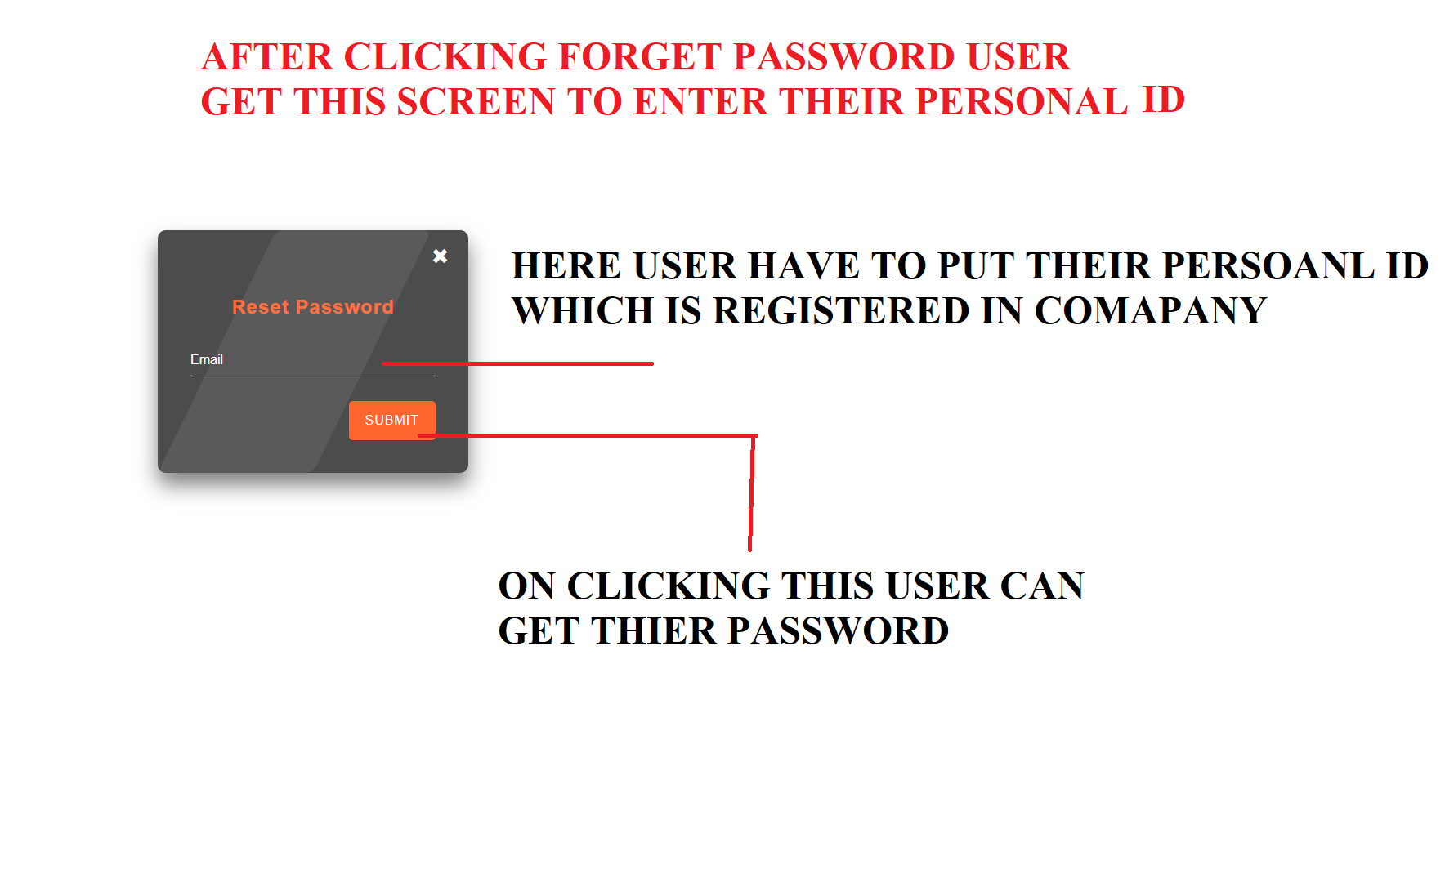

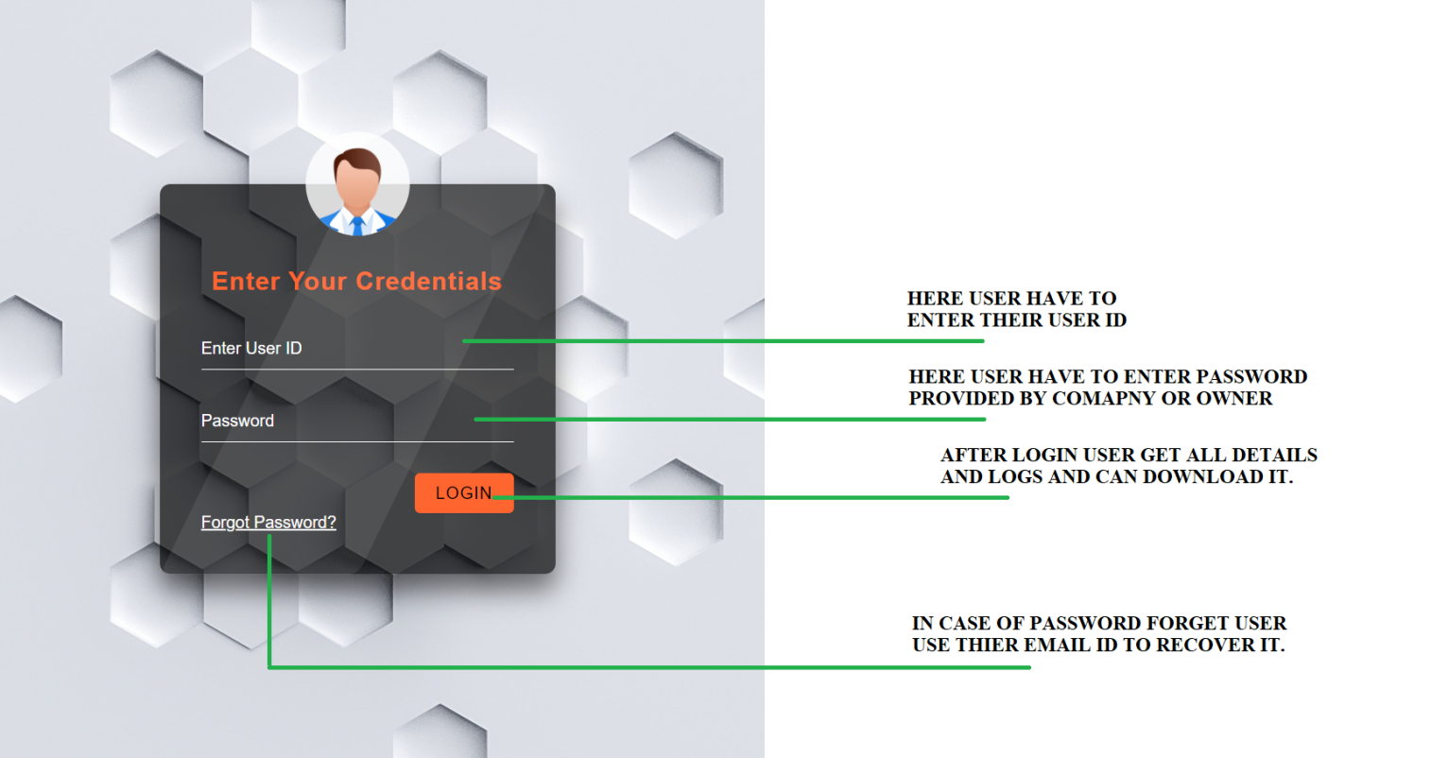

**SMARTPHONE APPLICATION UI**

**SCREEN 1**

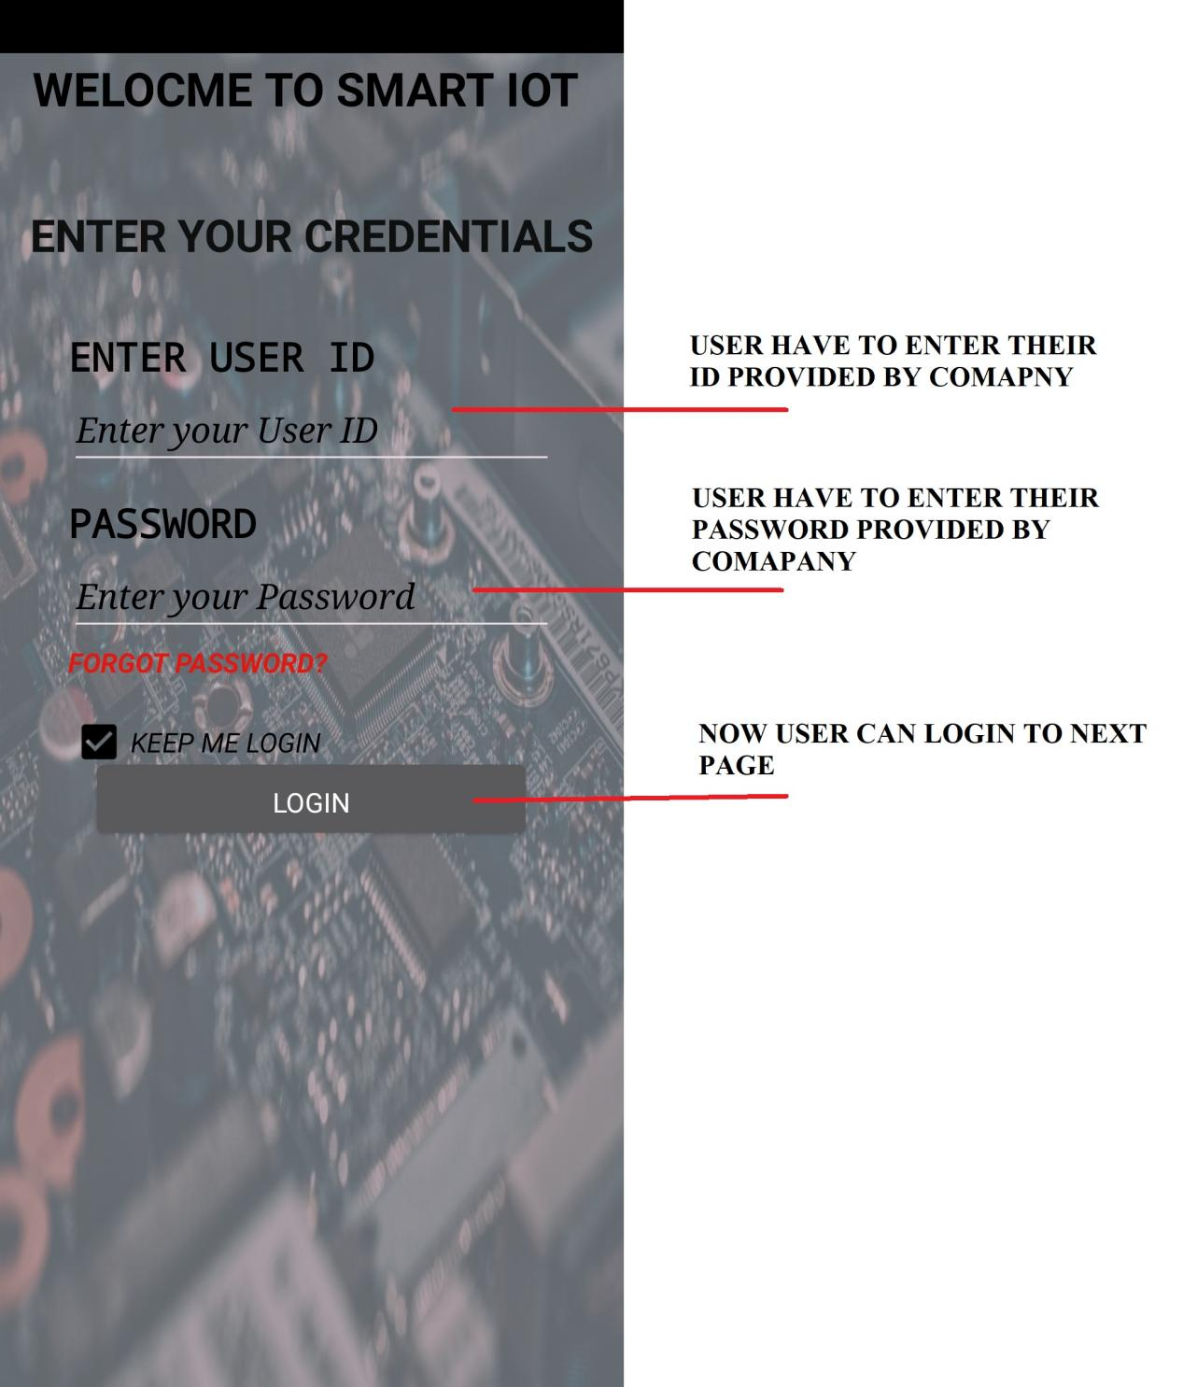

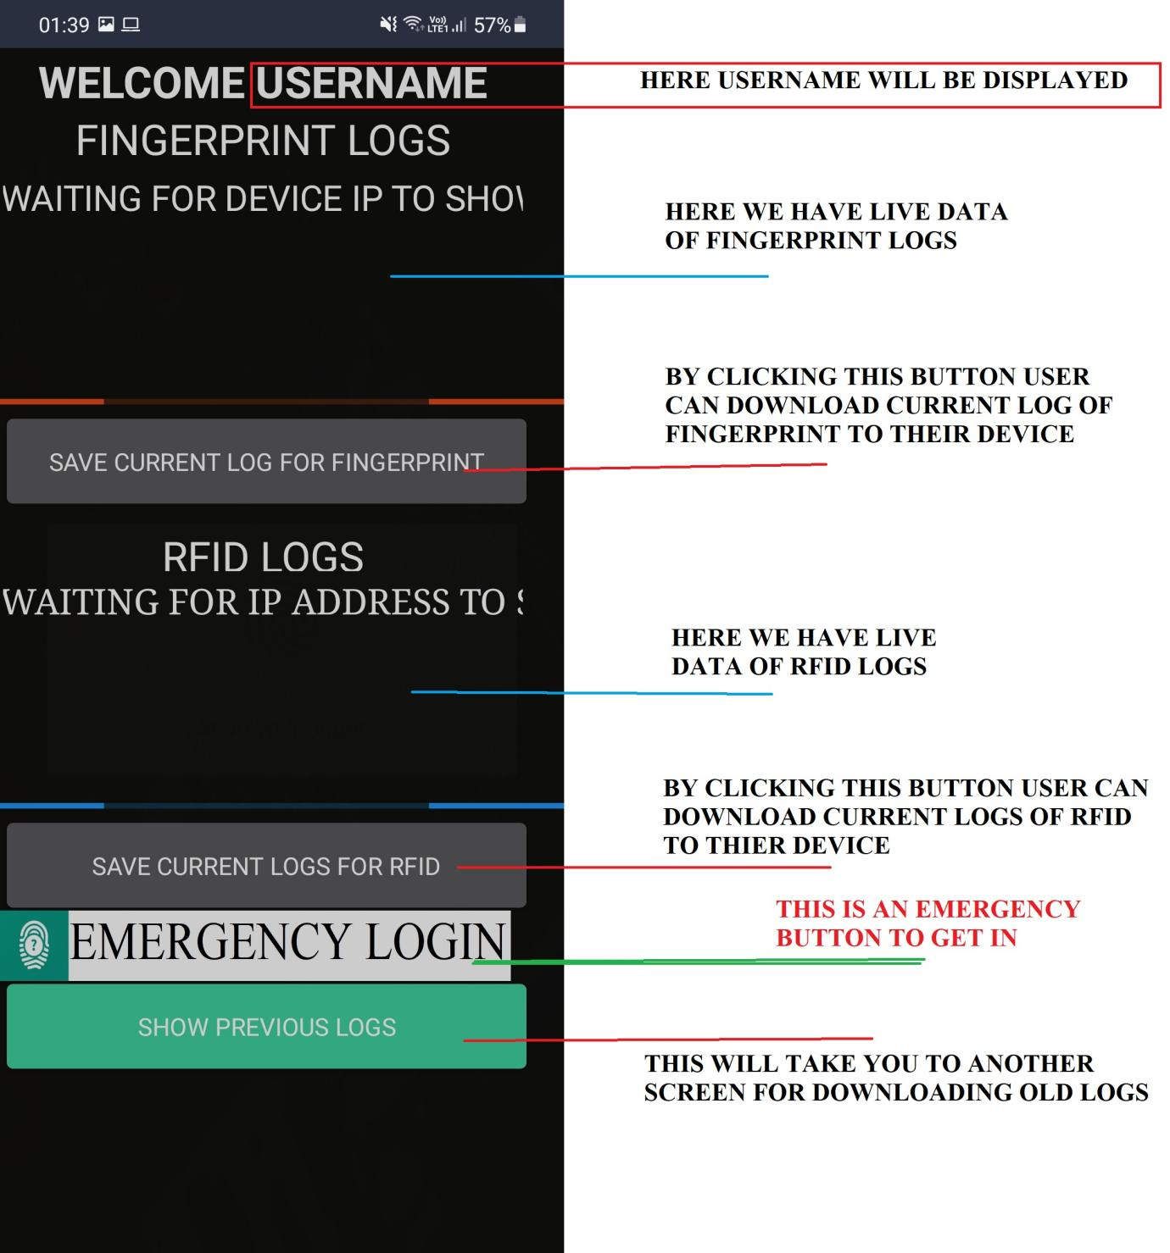**SCREEN 2 : AFTER LOGIN**

**SCREEN 3: WHEN CLICKING EMERGENCY LOGIN**

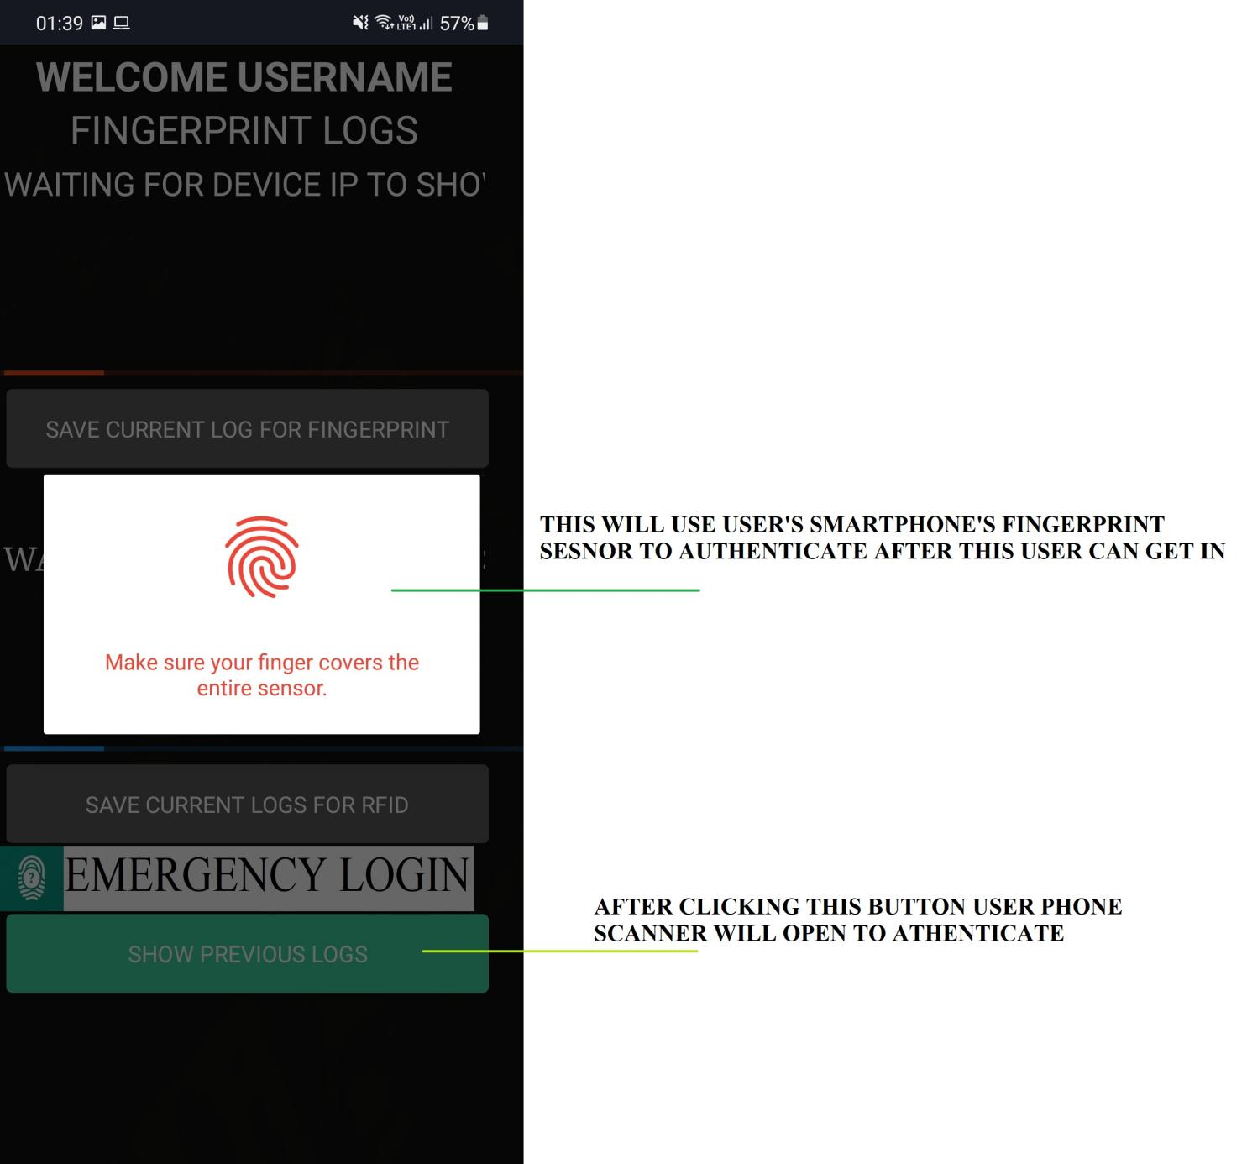

**SCREEN 4: AFTER CLICKING “SHOW PREVIOUS RECORDS”**

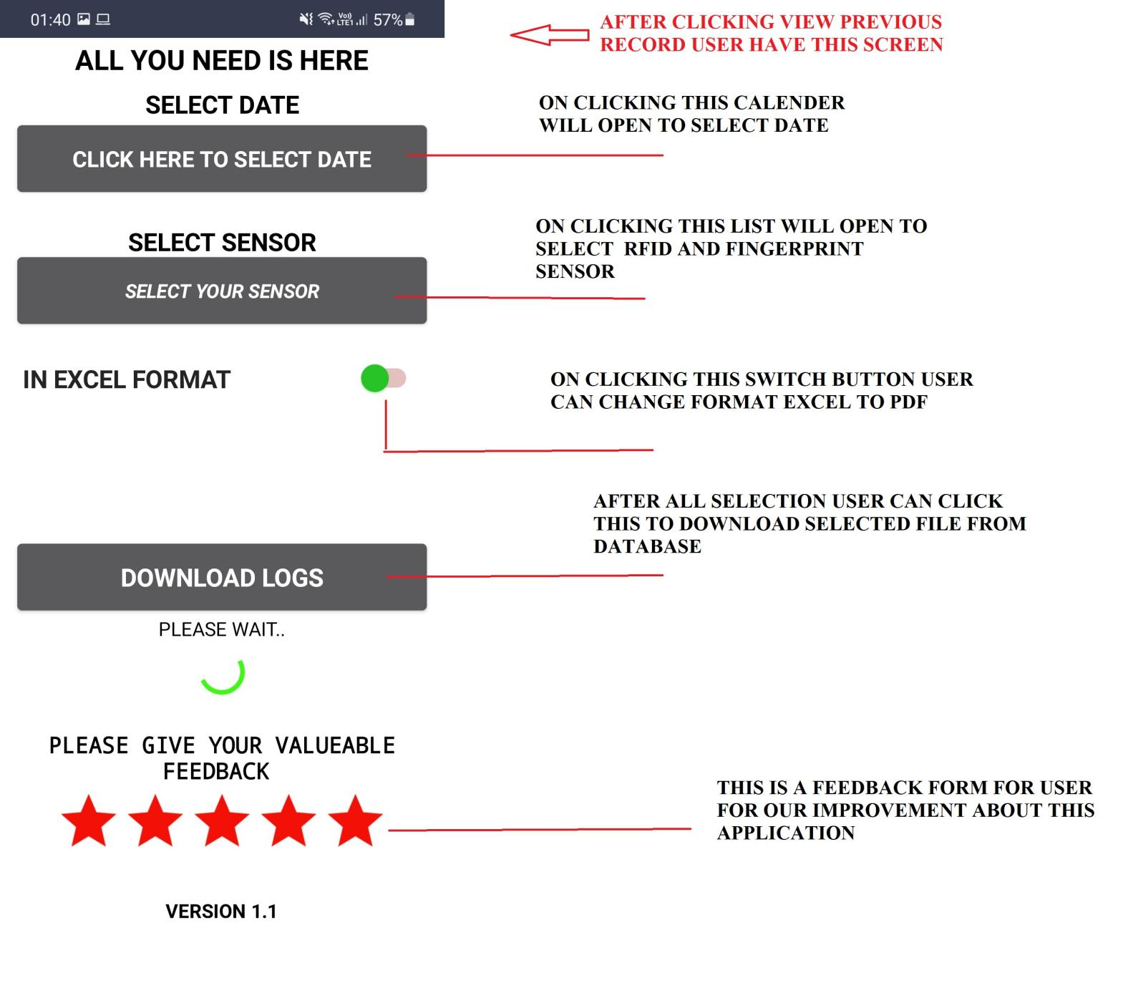

**UPLOADING DATA TO XAMPP**

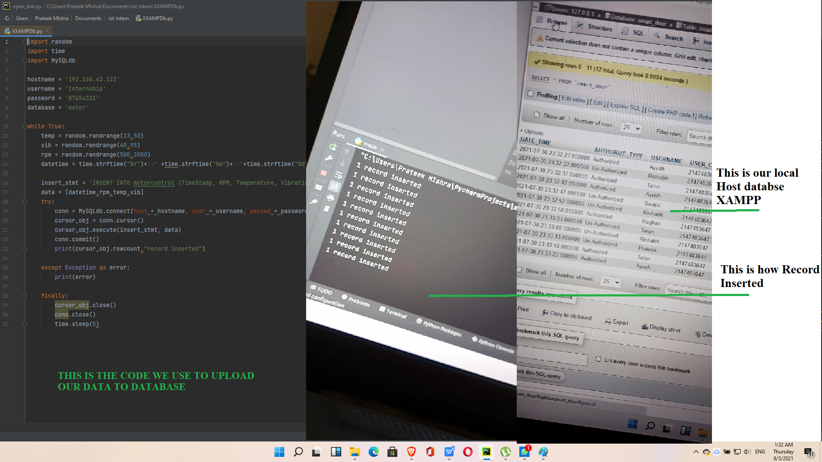

**COMPLETE CIRCUIT DESIGN**

**WE CREATED A CIRCUIT DIAGRAM TO MAKE BETTER UNDERSTANDING WHAT WE ARE DOING ACTUALLY:**

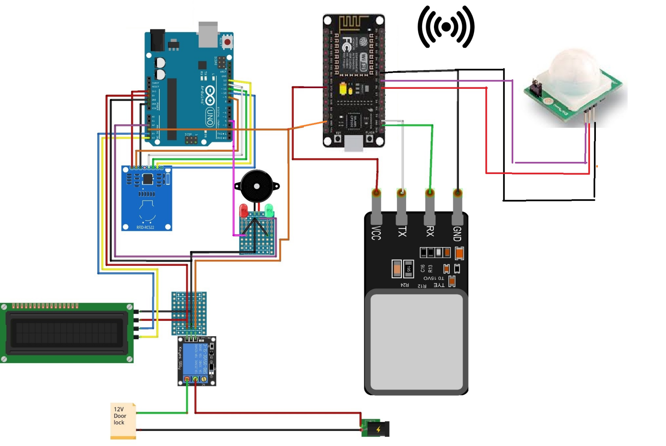

**BENEFITS OF OUR PROJECT**

**(SMART DOOR AUTOMATION)**

#### ENSURES YOU A HIGH SECURIT

#### CONVENIENT FOR ELDERLY AND PHYSICALLY IMPAIRED PEOPLE

#### FAST OPENING / CLOSING TIMES

#### STRICT CONTROL OF IN / OUT

#### EASY TO USE

#### GIVE ALERT FOR UNAUTHORIZED ACCESS

**CONCLUSION**

A step by step approach in designing the micro-controller-based system for securing the Transactions of the user and providing the security for the locker system and even more for the Passport verification using a finger print scanner has been followed. The result obtained in Providing the security is quite reliable in all the three modes. The system has successfully Overcome some of the aspects existing with the present technologies, using finger print Biometric as the authentication Technology.

The aim of the work is to design a fingerprint lock system that can be used to lock and unlock a door system, but its use can be extended to other electronic locking systems such as vaults. Having realized the device and found it working properly according to its design specifications and couple with the facts that relatively cheap components were involved in its realization, the aim of the research can be said to be achieved. The system can be used as an effective security lock.

**=========================================THE END===========**

**LINK FOR COMPLETE PROJECT**

**Presentation :**

**Android Application :**

**WEB Login portal :**

**Circuit Diagram :**

**Report :**

**Source Code :**

**All Images :**